## **SAP - APPROVAL WORKFLOW**

**Menu**

1. **Masters:**

* Company Master
  + Data Addition without Error. - Test Pass
  + Edit the record without Error. - Test Fail
    - Fail Reson.
  + Company code duplicate should not allow
  + Company code Should not be edited.
  + Active / In-active can be enable while edit.
  + Access to be Admin User Only.
* Business Decision
* Plant
* Department
* User
* Role
* Material
* Vendor
* Customer
* Storage Location
* Movement Type
* Movement List Items
* Cost Center
* Valuation Type
* Supervisor Code
* Module
* Line
* Translation

1. **Transitions:**

* 309 Movement Transition
* 201 Movement Transition
* 202 Movement Transition
* 551 Movement Transition
* 311 Movement Transition
* Conversion Rs.1
* Inward Of Old Invoices
* Emergency Procurement

### **Approval**

* 309 Approval
* 201 Approval
* 202 Approval
* 551 Approval
* 311 Approval
* Conversion Rs.1 Approval
* Inward Of Old Invoices Approval
* Emergency Procurement Approval

### **Store Dashboard**

**Tabs (Based On Plant):**

* **Store 1:**
  + Store Open
  + Store Closed
* **Store 2:**
  + Store Open
  + Store Closed

### **Production Plan**

### **Approved Reports**

### **Reports**

* 309 Report
* 201 Report
* 202 Report
* 551 Report
* 311 Report
* Inward Of Old Invoices Report
* Emergency Procurement Report
* Conversion Rs.1 Report

1. **Approved Report**

### **SAP Login**

### **Masters**

### **Company**

### **Creation / Updation**

Test case - 1 :

1.**Company Code** Unique (Not Allowing Duplicate) PASS

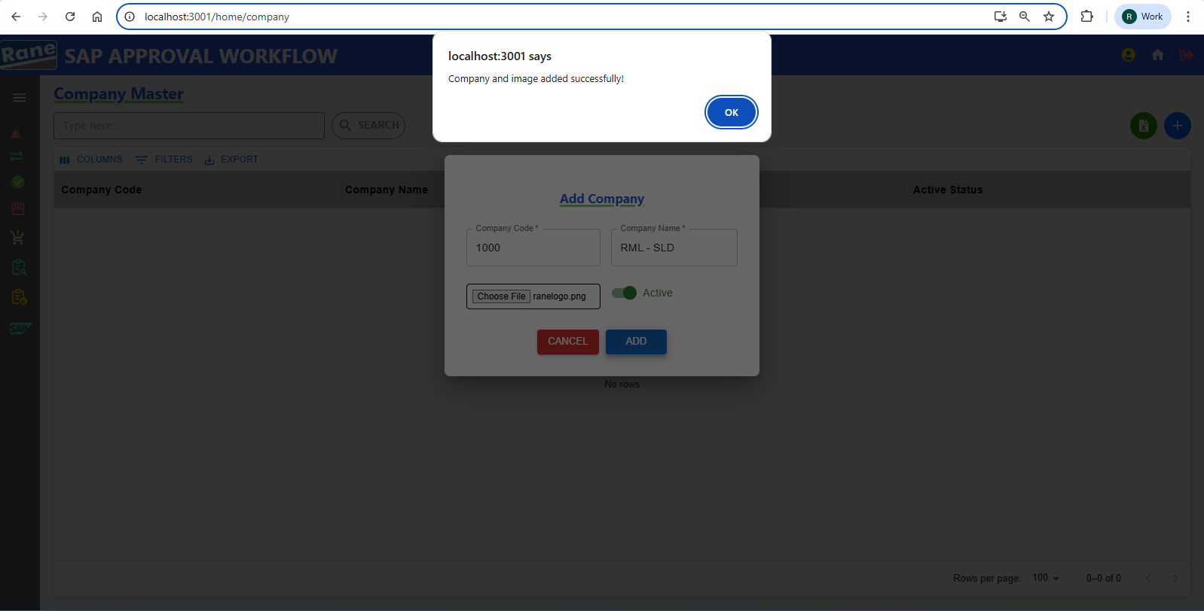

2. Update **Company Name** and **Active Status**  PASS

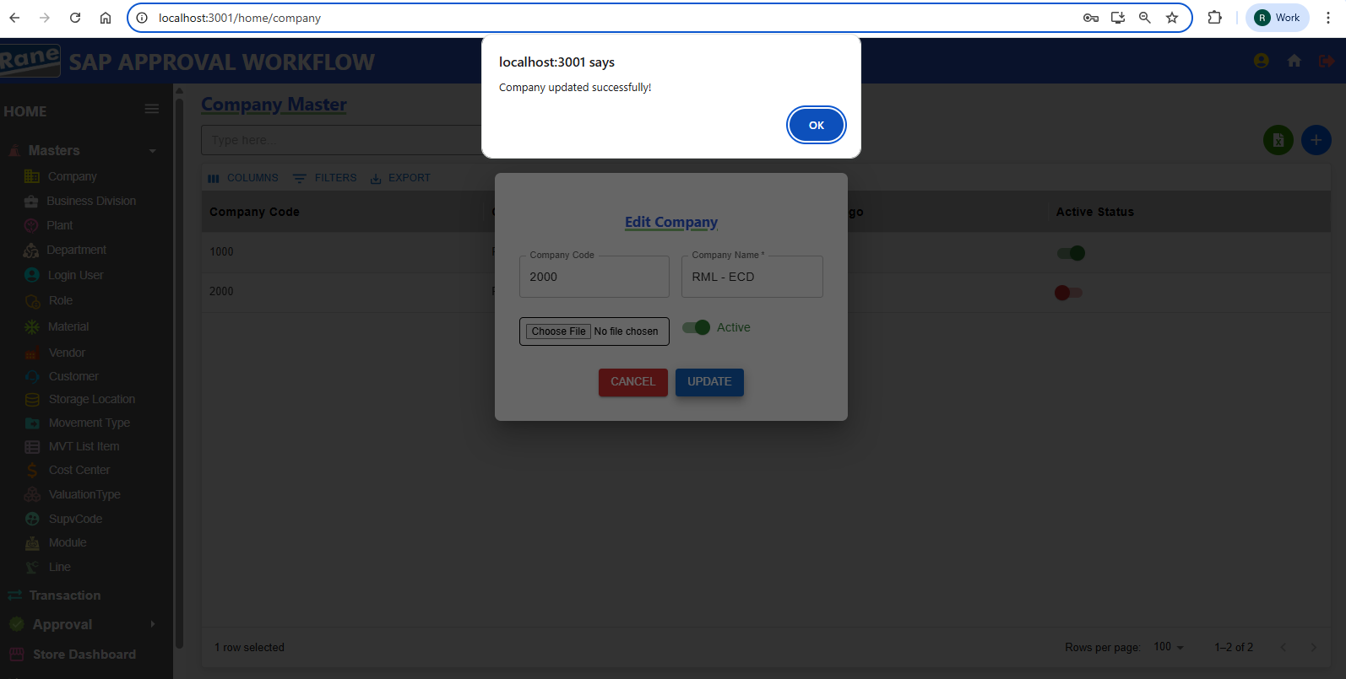

### Company Code - Disabled **(Read-Only)** PASS

### Company Name - **Editable** PASS

Company Logo - **Editable** PASS

If the user needs to change the Company Logo , they must choose a file and update it.

Otherwise, for any other updates, changing the Company Logo is not required.

### **Business Decision**

### **Creation / Updation**

Test case - 2 :

1.**Business Division Code** Unique and (Not Allowing Duplicate) PASS

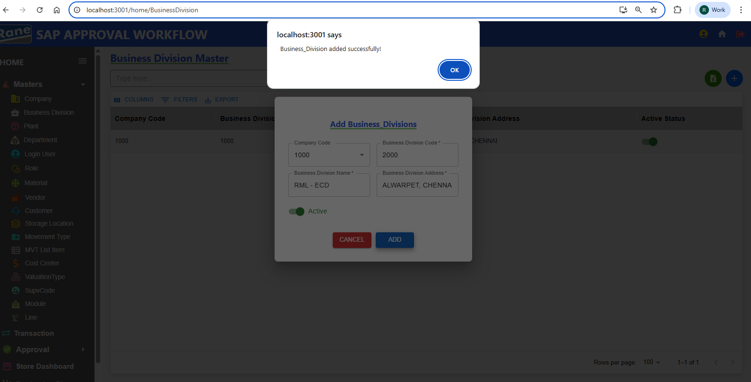

2.**Business Division Code -** Each Business Division Code must be unique within its associated Company Code. If a code already exists under the same Company Code, duplicate INSERTION IS NOT ALLOWED. PASS

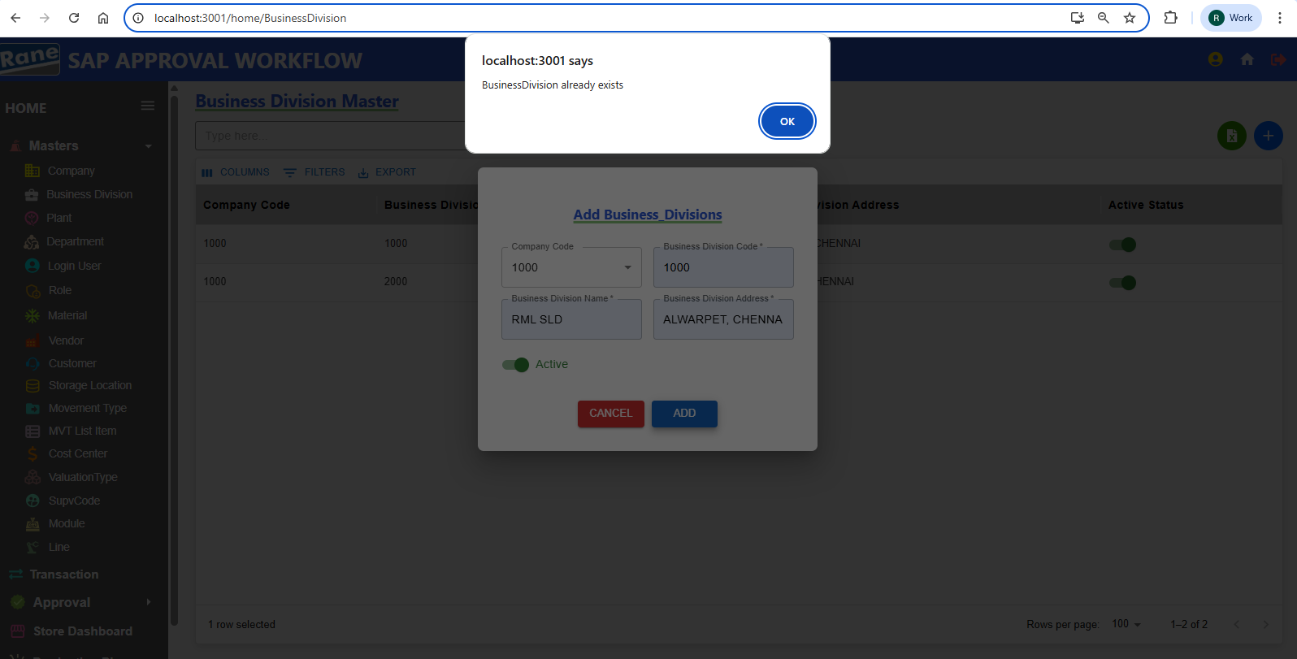

2. Update **Business Division Address** and **Active Status**  PASS

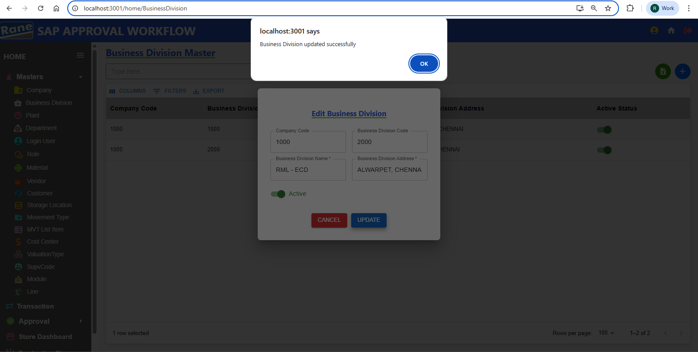

Company code - Disabled **(Read-Only)** PASS

Business Division Code - Disabled **(Read-Only)** PASS

Update Business Division Address - **Editable** PASS

Update Active Status - **Editable** PASS

**Plant**

### **Creation / Updation**

Test case - 3 :

1. **Plant Code** Unique(Not Allowing Duplicate) PASS

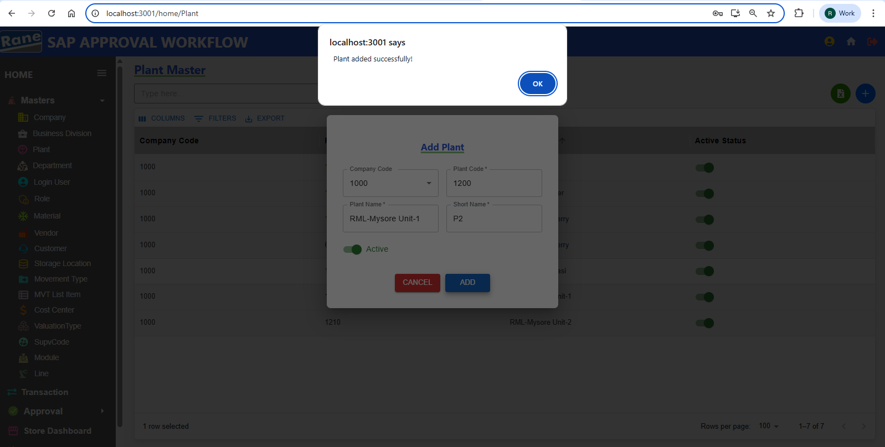

1. **Plant Code** If the same Plant Code already exists for the selected Company, INSERTION IS NOT ALLOWED. PASS

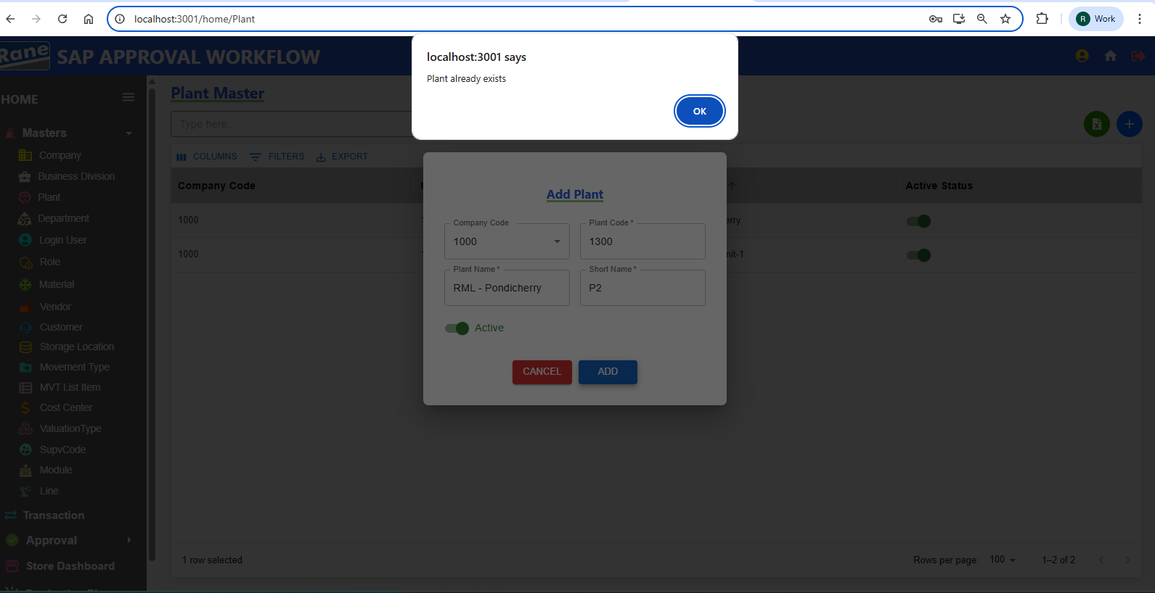

1. Update **Plant Name** and **Short_Name** PASS

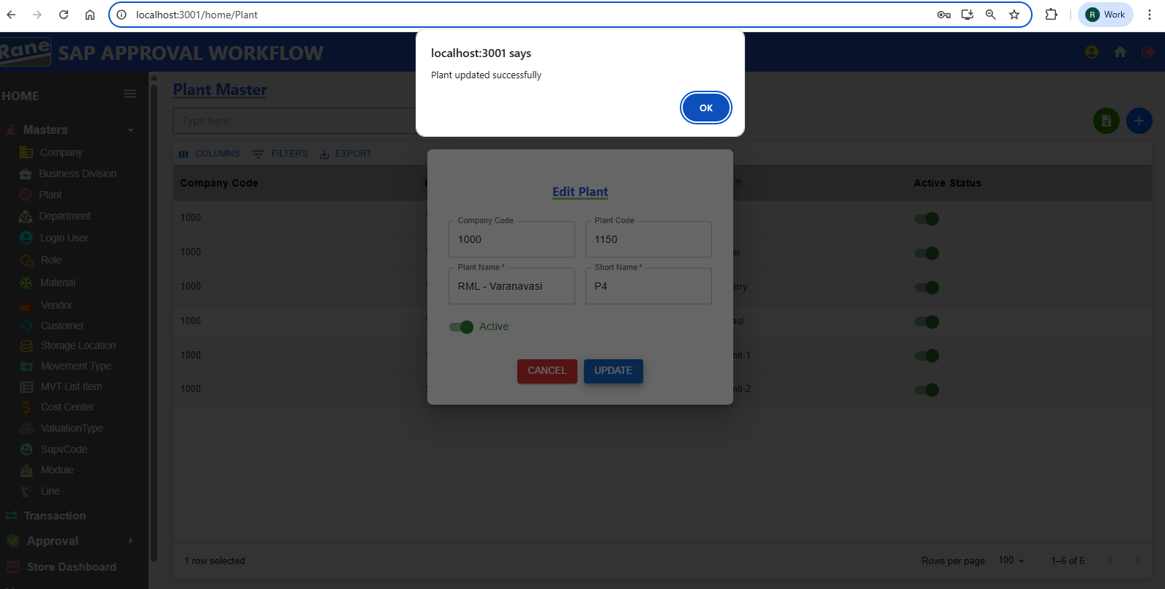

Company code - Disabled **(Read-Only)** PASS

Plant Code - Disabled **(Read-Only)** PASS

Update Plant Name - **Editable** PASS

Update Short Name - **Editable** PASS

Update Active Status - **Editable** PASS

**Department**

### **Creation / Updation**

Test case - 4 :

1. **Plant Code** Unique(Not Allowing Duplicate) PASS

Department code 3 digits ?????

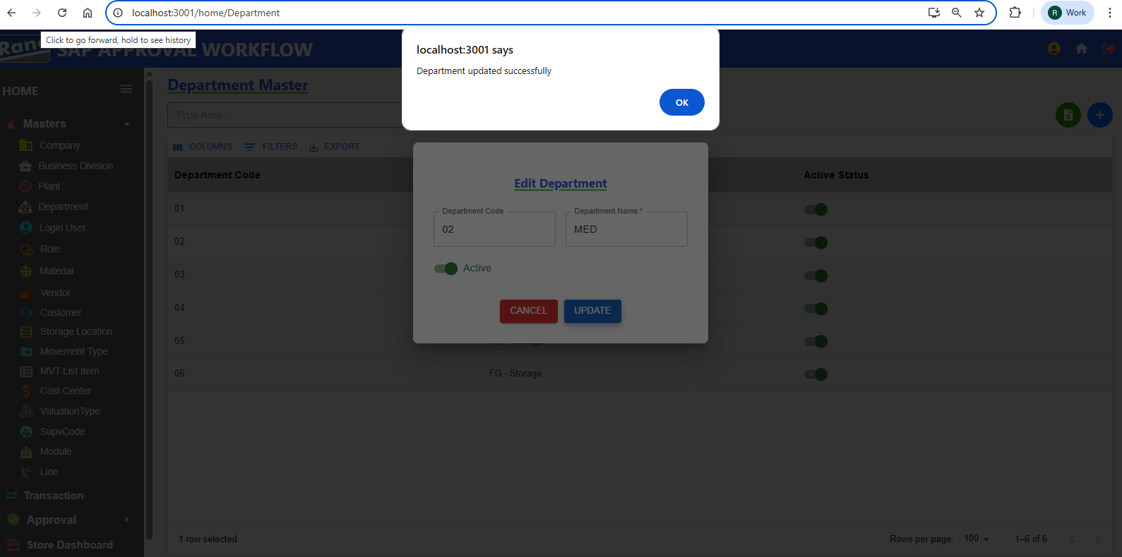

**User**

### **Creation / Updation**

Test case - 5 :

1. Employee ID Unique(Not Allowing Duplicate) PASS

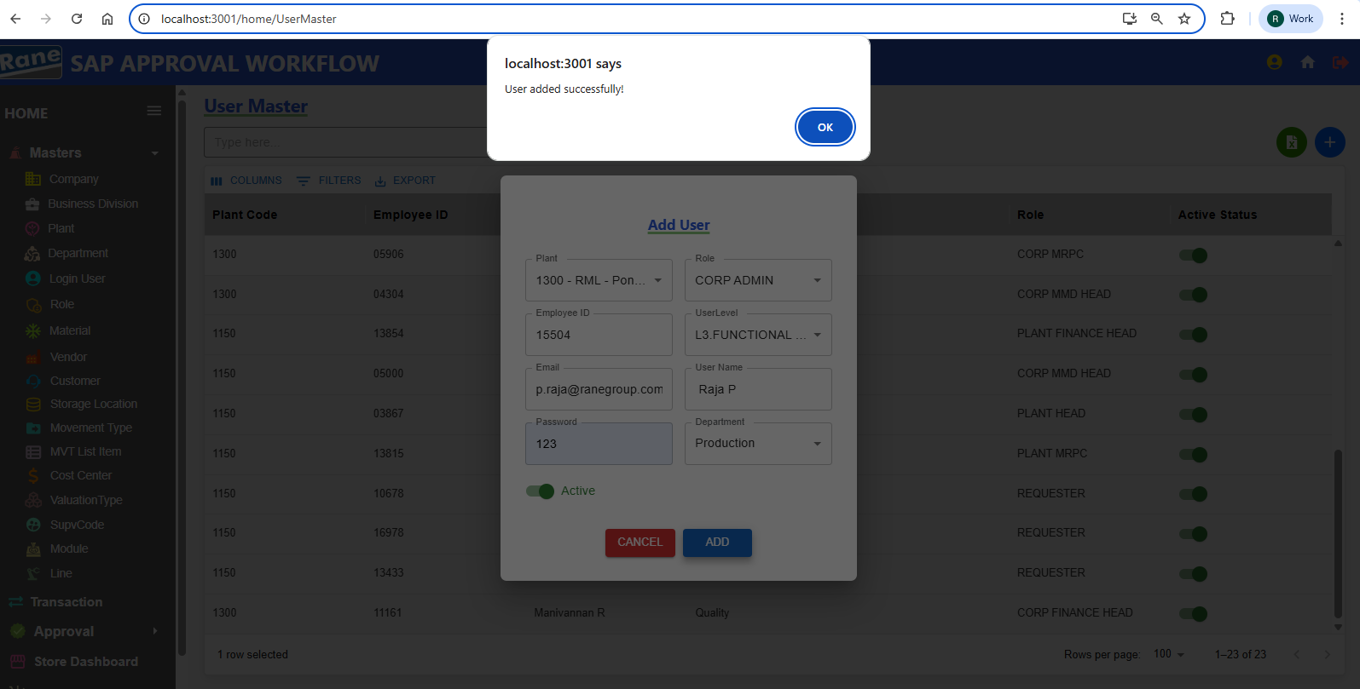

1. If The Employee ID Is Already Present In The User Master For The Selected Plant, New User INSERTION WILL NOT BE ALLOWED. PASS

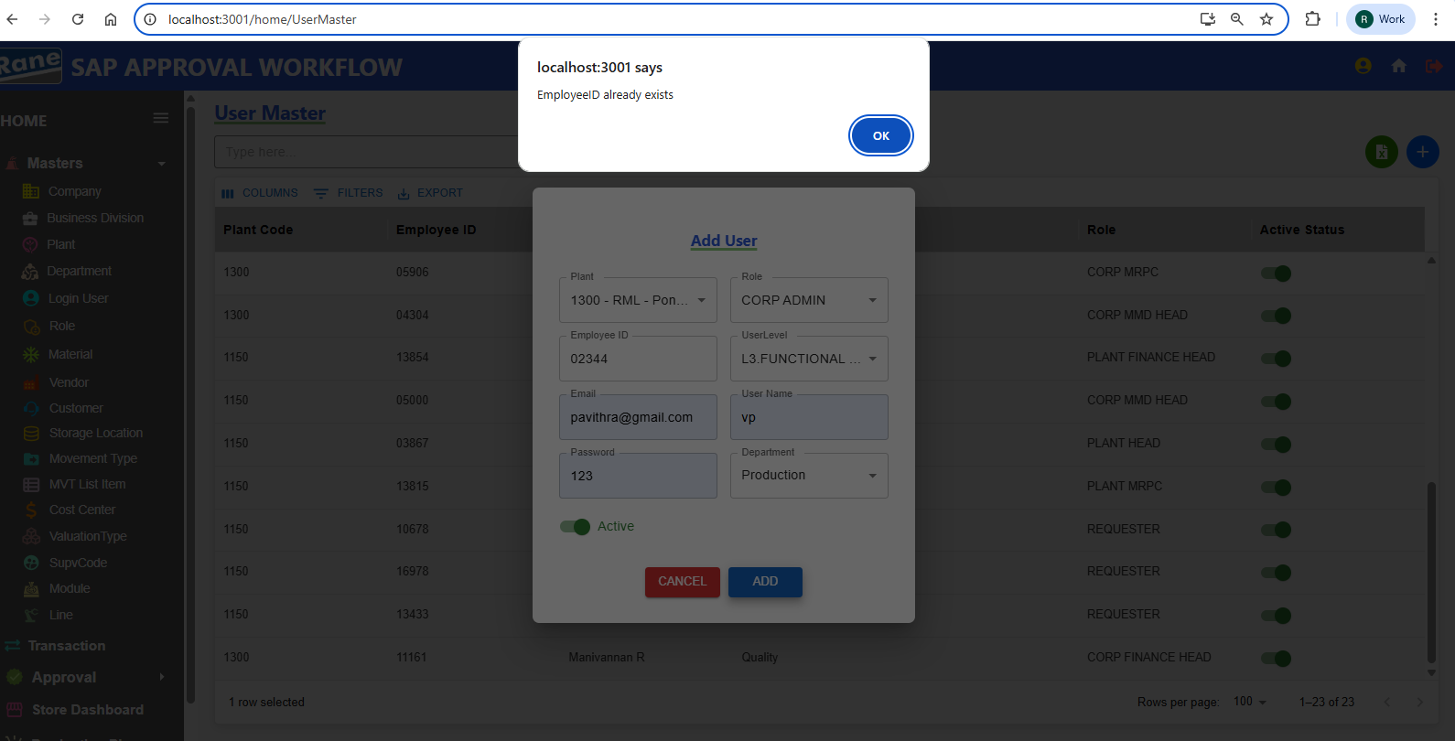

1. Update User Details PASS

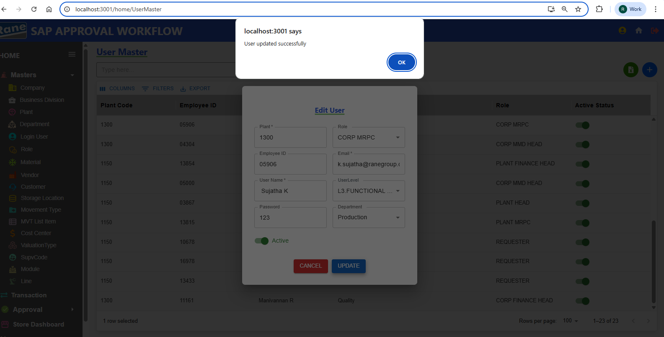

Plant code - Disabled **(Read-Only)** PASS

Employee - Disabled **(Read-Only)** PASS

Updation Role - **Editable** PASS

Updation Email - **Editable** PASS

Updation User Name - **Editable** PASS

Updation User Level - **Editable** PASS

Updation Password - **Editable** PASS

Updation Department - **Editable** PASS

Updation Active Status - **Editable** PASS

**Role**

### **Creation / Updation**

Test case - 6 :

1. Role – If the Role Name already exists in the Role Master, INSERTION IS NOT ALLOWED as it is a duplicate. Active status can be either true or false .PASS

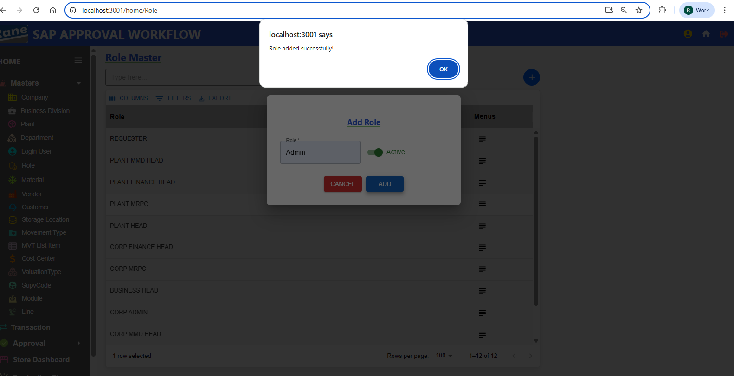

1. Updation Role Name and Active Status PASS

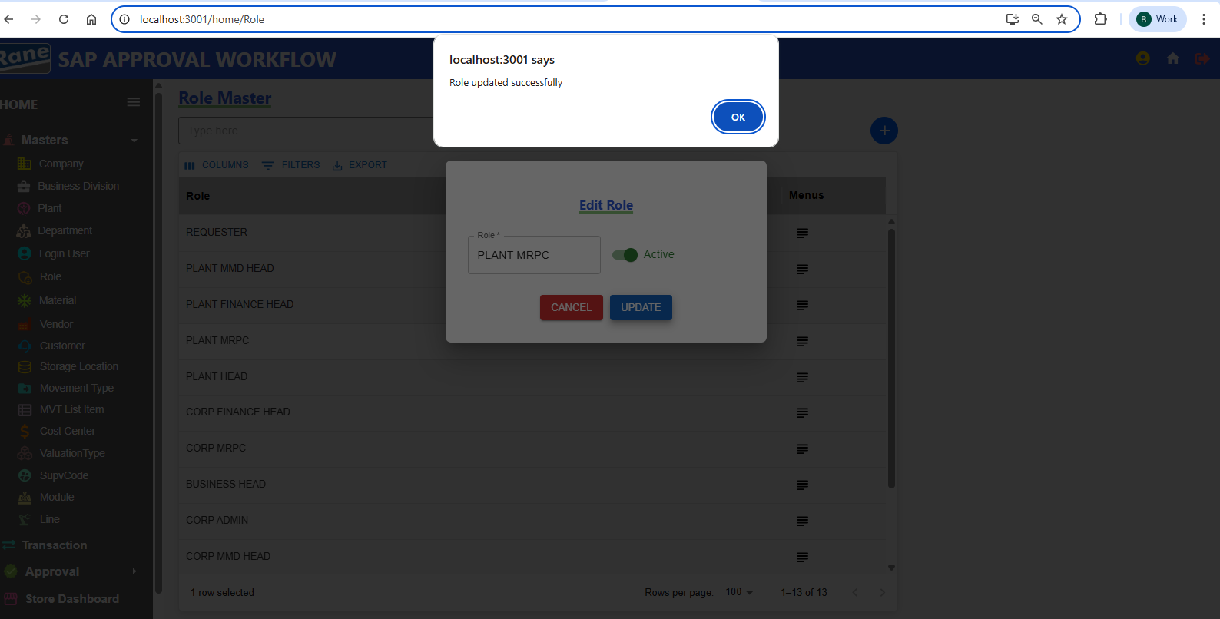

Updation Role - **Editable** PASS

Updation Active Status - **Editable** PASS

**Material**

### **Creation / Updation**

Test case - 7 : (Pending - Data)

**Vendor**

### **Creation / Updation**

Test case - 8 : (Pending - Data)

**Customer**

### **Creation / Updation**

Test case - 9 : (Pending - Data)

**Storage Location**

### **Creation / Updation**

Test case - 10 :

1. **Storage Code** Unique(Not Allowing Duplicate) PASS

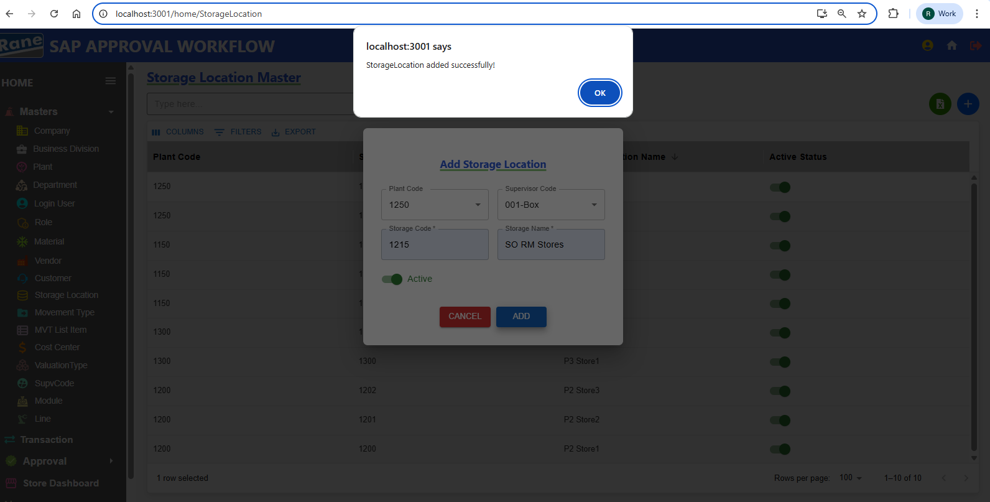

1. Storage Code Is Unique Based On The Plant. If The Storage Code Already Exists In The Selected Plant, INSERTION IS NOT ALLOWED As It Is A Duplicate.

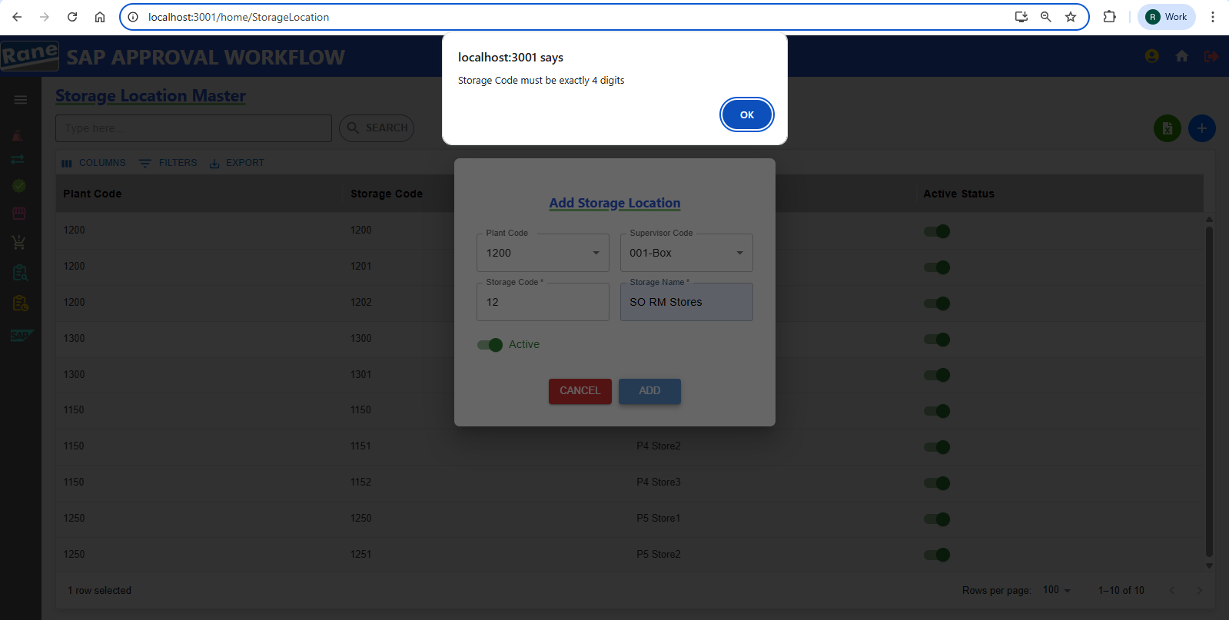

**Storage Code**  Must Be 4 Digits PASS

1. Update Storage Location PASS

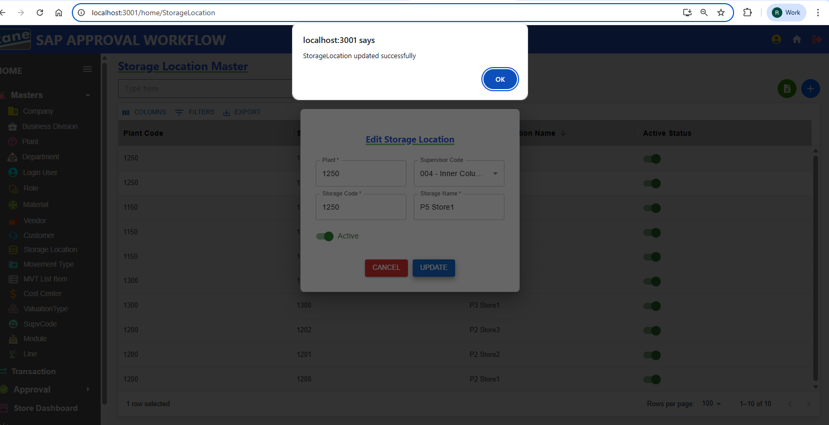

Storage code - Disabled **(Read-Only)** PASS

Plant Code - Disabled **(Read-Only)** PASS

Updation Storage Location Name - **Editable** PASS

Updation Supervisor Code - **Editable** PASS

Updation Active Status - **Editable** PASS

**Movement Type**

### **Creation / Updation**

Test case - 11 :

1. Movement Code Unique(Not Allowing Duplicate) PASS

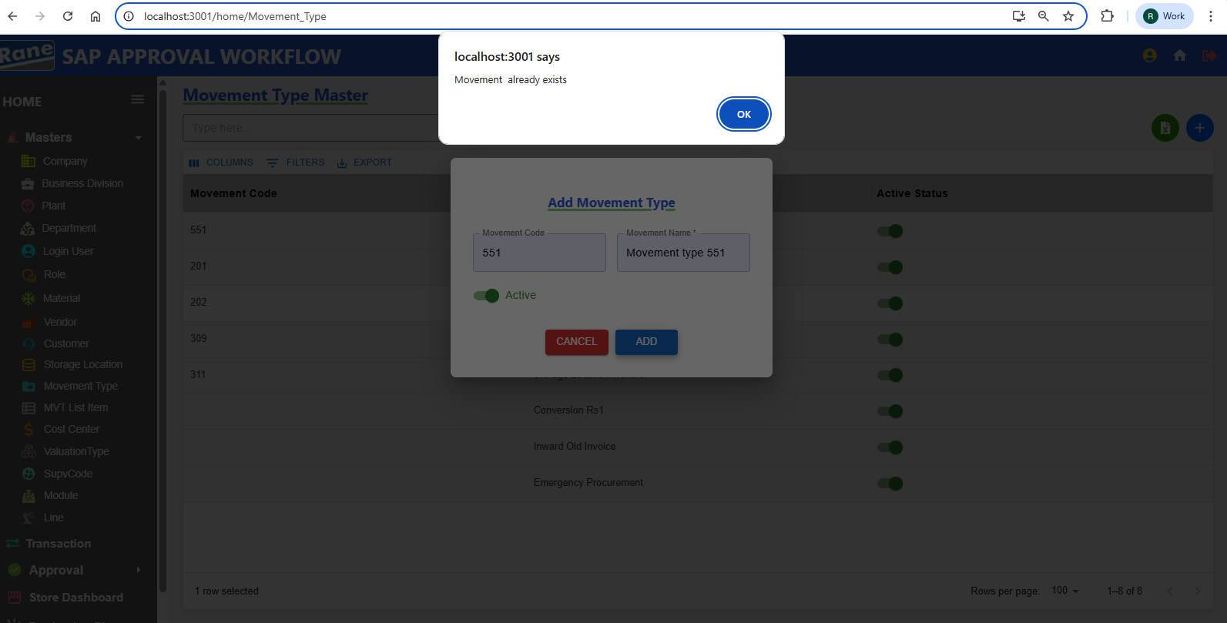

1. Update Movement Type PASS

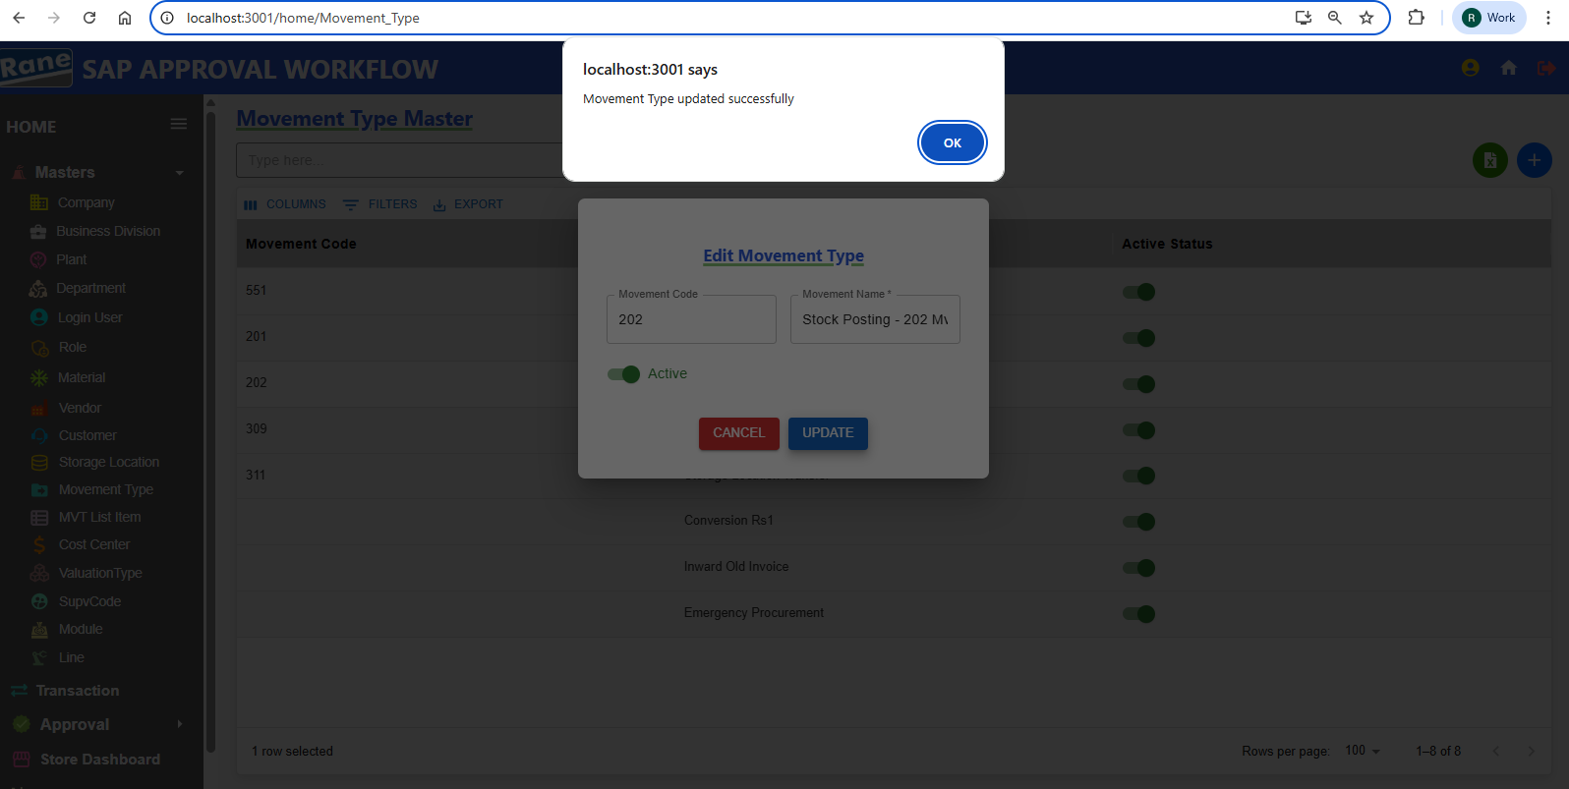

Movement Code - Disabled **(Read-Only)** PASS

Update Movement Name - **Editable** PASS

Updation Active Status - **Editable** PASS

**Movement List item**

### **Creation / Updation**

Test case - 12 : (Pending - Data)

**Cost Center**

### **Creation / Updation**

Test case - 12 : (Pending - Data)

**Valuation Type**

### **Creation / Updation**

Test case - 13 :

1. ValuationType Name Unique(Not Allowing Duplicate) PASS

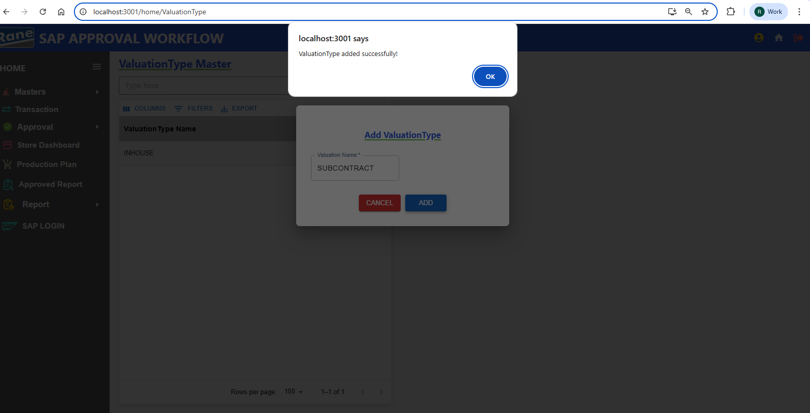

1. ValuationType Name Already Exists In The Valuation Master, INSERTION IS NOT ALLOWED As It Is A Duplicate. PASS

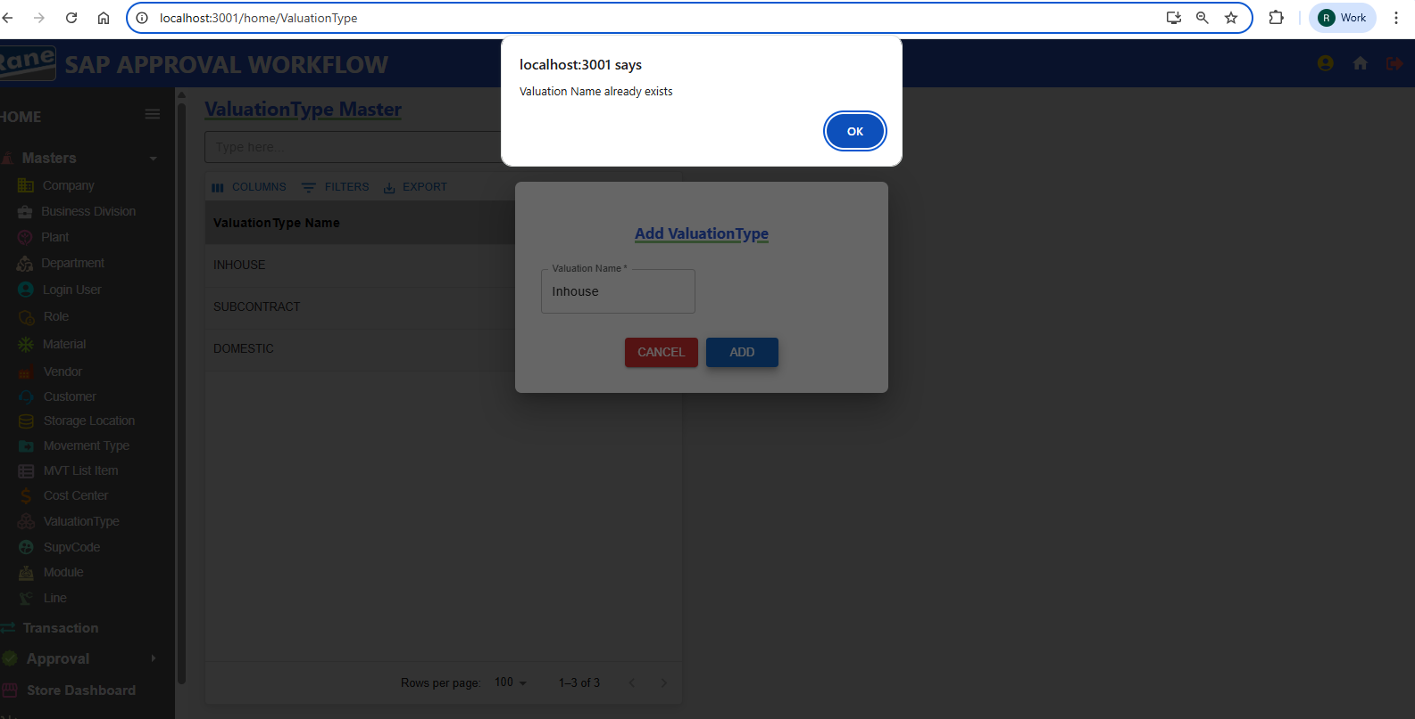

**Supervisor Code**

### **Creation / Updation**

Test case - 14 : (Pending - Data)

**Module**

### **Creation / Updation**

Test case - 15 :

1. Insert Name Based on ??????? Unique

2. Update **Module** PASS 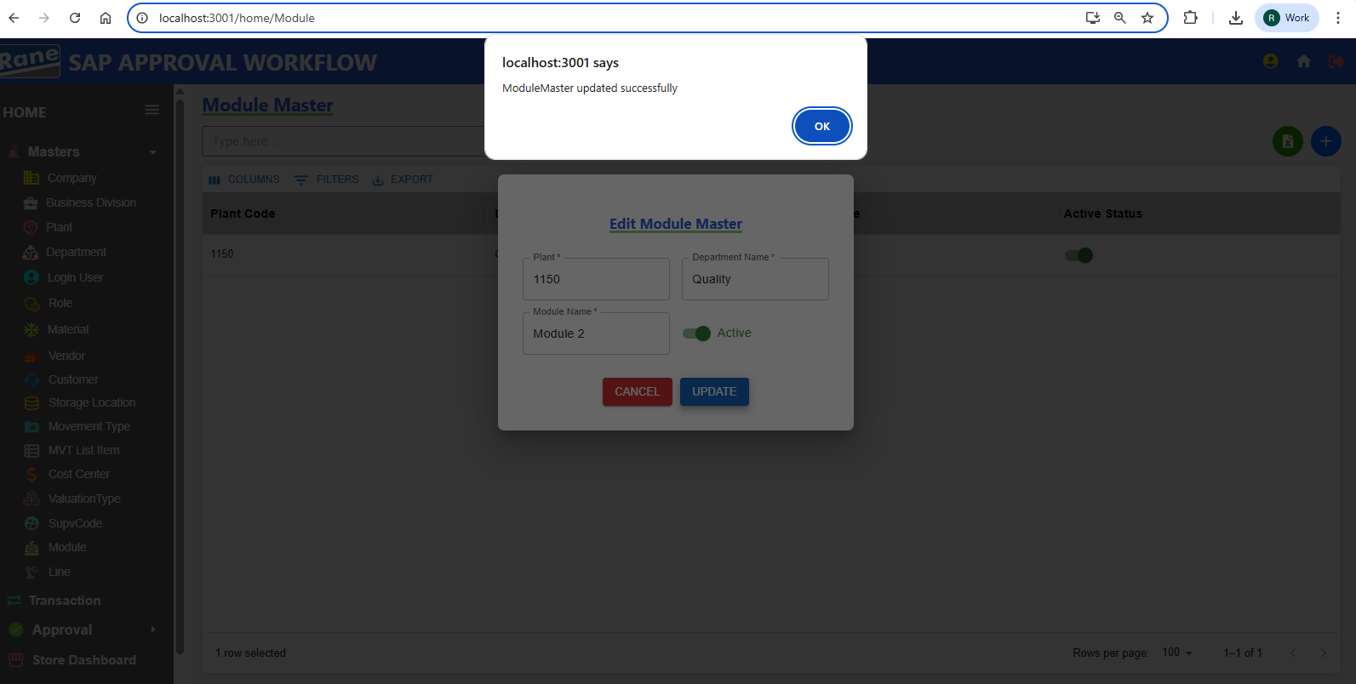

PlantCode - Disabled **(Read-Only)** PASS

Department Name - Disabled **(Read-Only)** PASS

Updation Module Name - **Editable** PASS

Updation Active Status - **Editable** PASS

**Line**

### **Creation / Updation**

Test case - 16 : (Pending - Data)

1. Create Insert Name Based on ??????? Unique
2. Update Line

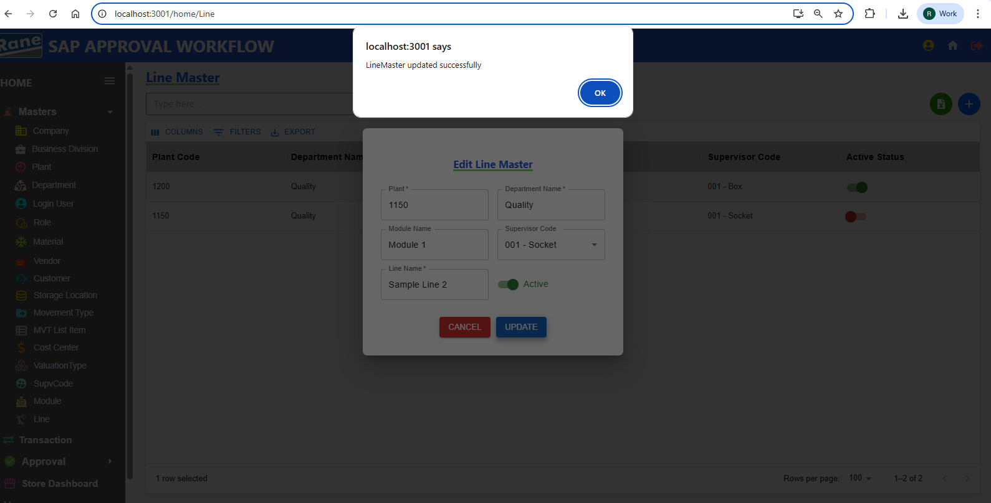

Plant Code- Disabled **(Read-Only)** PASS

Module Name - Disabled **(Read-Only)** PASS

Department Name - Disabled **(Read-Only)** PASS

Updation Supervisor Code- **Editable** PASS

Updation Line Name - **Editable** PASS

Updation Active Status - **Editable** PASS

**2.Transitions**

**309 Movement Transitions**

### **Creation / Updation**

**Test case - 1 :**

**201 Movement Transitions**

### **Creation / Updation**

**Test case - 2 :**

**202 Movement Transitions**

### **Creation / Updation**

**Test case - 3 :**

**551 Movement Transitions**

### **Creation / Updation**

**Test case - 4 :**

**311 Movement Transitions**

### **Creation / Updation**

**Test case - 5 :**

**Conversion Rs.1 Transitions**

### **Creation / Updation**

**Test case - 6 :**

**Inward Od Old Invoices**

### **Creation / Updation**

**Test case - 7 :**

**Emergency Procurement**

### **Creation / Updation**

**Test case - 8 :**

**____________________________________________________________**

### **Approval**

* 309 Approval
* 201 Approval
* 202 Approval
* 551 Approval
* 311 Approval
* Conversion Rs.1 Approval
* Inward Of Old Invoices Approval
* Emergency Procurement Approval